Accommodation establishments as of 31 July 2020 and their occupancy in the first half of 2020

(concerns tourist accommodation establishments with 10 or more bed places)

In the first half of 2020, 7.3 million tourists were accommodated in tourist accommoda-tion establishments and 19.4 million overnight stays were provided for them. Compared to the same period 2019, this was lower by 54.3% and 51.5% respectively. Compared to the first half of 2019, the occupancy rate of accommodation establishments also de-creased from 37.6% to 23.8%.

 54.3%

Decrease in the number of tourists in accommodation establishments in the first half of 2020 compared to the corresponding period last year.

Tourism is one of the sectors directly affected by the COVID-19 pandemic. The restrictions on the movement of people introduced in Poland in mid-March this year and the reduction in activities related to the provision of hotel services since the beginning of April resulted in a significant decrease in the number of persons accommodated in tourist accommodation establishments. After the above restrictions were lifted in May, some accommodation establishments did not resume operations and, despite a gradual increase in the number of tourists accommodated in accommodation establishments, the occupancy of establishments did not reach the level of the same periods last year.

# **Tourist accommodation establishments - end of July 2020**

As of 31 July 2020, there were 10291 tourist accommodation establishments in Poland with 775.3 thousand bed places

At the end of July 2020, 10291 tourist accommodation establishments were operating in Poland, i.e. by 8.5% (960 establishments) less than a year ago. The most significant decrease was in the number of hostels (by 18.9%), school youth shelters (by 17.9%) and other tourist accommodation establishments, e.g. boarding schools, student dormitories (by 15.4%). Among the establishments operating in July, most were hotels (2498), followed by guest rooms (2149), holiday centres (1020) and other hotel establishments (983).

Most tourist accommodation establishments were located in Pomorskie Voivodship (1555), Zachodniopomorskie Voivodship (1484), Małopolskie Voivodship (1362) and Dolnośląskie Voivodship (1012). These voivodships concentrated half of the country's accommodation establishments.

In July, 775.3 thousand bed places were prepared for tourists, including 225.2 thousand seasonal bed places. The largest number of bed places was available in hotels (276.4 thousand) and holiday centres (122.3 thousand). Compared with the end of July 2019, the number of bed places decreased by 6.1%. The decrease concerned almost all types of establishments, except for boarding houses and complexes of tourist cottages, where the number of bed places remained unchanged, as well as hostels, which offered about 11% more places than a year ago.

The largest number of bed places available for tourists was in Zachodniopomorskie Voivodship (141 thousand), Pomorskie Voivodship (116 thousand) and Małopolskie Voivodship (95 thousand).

Tourist accommodation establishments in Poland are medium-sized - on average they have 75 bed places. The largest are health establishments with an average of nearly 200 bed places, camping sites with over 150 bed places as well as holiday youth centres with 140 bed places and holiday centres with 120 bed places. Hotels have 111 bed places and 54 rooms, on average.

As of 31 July this year, there were 7195 catering facilities in tourist accommodation establishments, i.e. 774 fewer than in the previous year. The largest group of facilities were restaurants - 3134, i.e. 43.6% of all facilities, and bars and cafés - 1979 (27.5%).

Map 1. Bed places in tourist accommodation establishments in 2020 – as of 31 July

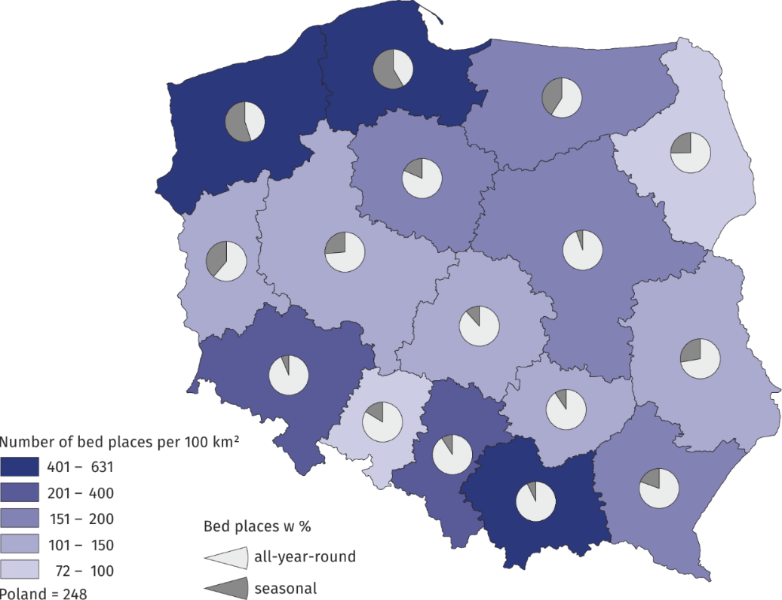

# **Occupancy of tourist accommodation establishments in the first half of 2020**

In the period January-June 2020, 7.3 million people were accommodated in tourist accommodation establish-ments, of which 1.1 million came from abroad

In the first half of 2020, 7.3 million people were accommodated in tourist accommodation establishments, i.e. 54.3% less than in the same period last year. In January and February this year, there was an approximately 8% increase in the number of persons accommodat-ed. Starting from March, the number of tourists in accommodation establishments started to fall sharply, reaching its lowest level in April (96.5% drop), when most of the establish-ments suspended their operations due to the COVID-19 pandemic. Since May this year, there has been an increase in the number of persons accommodated, but their number in any month did not reach the level of a year ago.

Chart 1. Tourists accommodated in tourist accommodation establishments

In the period January-June 2020, most tourists were accommodated in hotels - 4.9 million, followed by other hotel establishments - 631.1 thousand and holiday centres - 365.6 thou-sand. About 200 thousand persons were accommodated in training and recreational cen-tres, health establishments and rooms for guests.

In comparison with the first half of 2019, the greatest drops (ca. 70%) in the number of persons accommodated were recorded in holiday youth centres, youth shelters and school youth shelters. Accommodation in boarding houses, shelters, health establishments, rooms for guest and agritourism lodgings was most frequently chosen with the number of tourists reaching over 50% of the same period last year.

The most popular voivodships among tourists were Małopolskie Voivodship and Mazowieckie Voivodship, with over 1 million tourists visiting them in the period January-June 2020. A large number of tourists were also accommodated in accommodation establishments in Dolnośląskie Voivodship – 878 thousand, Zachodniopomorskie Voivodship – 695 thousand and Pomorskie and Śląskie Voivodships – 660 and 622 thousand respectively.

Except from Zachodniopomorskie Voivodship, the decreases in the number of persons accommodated in the voivodships were over 50% compared with the corresponding period of last year.

Table 1. Tourists in tourist accommodation establishments in the first half of 2020

|  |  |  |  |  |  |  |
| --- | --- | --- | --- | --- | --- | --- |
| Voivodship | Total | | Domestic tourists | | Foreign tourists | |
| in thousand | first half of 2019=100 | in thousand | first half of 2019=100 | in thousand | first half of 2019=100 |
| **Poland** | **7339.1** | **45.7** | **6209.4** | **48.6** | **1129.6** | **34.5** |
| Dolnośląskie | 877.8 | 47.6 | 746.7 | 50.1 | 131.1 | 37.0 |
| Kujawsko-pomorskie | 289.8 | 46.6 | 272.3 | 47.7 | 17.5 | 34.1 |
| Lubelskie | 220.5 | 44.1 | 202.6 | 45.7 | 17.8 | 31.6 |
| Lubuskie | 139.3 | 44.1 | 108.8 | 47.5 | 30.5 | 35.1 |
| Łódzkie | 285.0 | 42.0 | 251.1 | 43.1 | 33.9 | 35.5 |
| Małopolskie | 1166.2 | 45.6 | 923.3 | 50.3 | 242.9 | 33.6 |
| Mazowieckie | 1045.6 | 40.1 | 816.2 | 43.1 | 229.4 | 32.4 |
| Opolskie | 87.3 | 42.8 | 76.1 | 43.5 | 11.3 | 38.2 |
| Podkarpackie | 277.6 | 48.9 | 251.1 | 50.2 | 26.5 | 39.4 |
| Podlaskie | 139.1 | 47.0 | 116.5 | 50.1 | 22.6 | 35.7 |
| Pomorskie | 659.5 | 49.8 | 579.5 | 54.2 | 80.0 | 31.4 |
| Śląskie | 622.4 | 46.2 | 552.0 | 48.0 | 70.4 | 35.6 |
| Świętokrzyskie | 132.4 | 42.2 | 125.5 | 42.6 | 6.9 | 36.5 |
| Warmińsko-mazurskie | 276.8 | 48.6 | 260.3 | 51.3 | 16.5 | 26.5 |
| Wielkopolskie | 424.5 | 42.8 | 373.5 | 43.5 | 51.0 | 37.9 |
| Zachodniopomorskie | 695.2 | 52.6 | 553.9 | 58.2 | 141.4 | 38.1 |

In the first half of 2020, 65.5% less foreign tourists were accommodated in tourist accommodation establishments than in the same period of 2019

Among the total number of tourists accommodated in the first half of this year, 84.6% were domestic tourists (6.2 million) and 15.4% were foreign tourists (1.1 million), and in compar-ison with the corresponding period of last year, this was less by 51.5% and 65.5% respec-tively. The overall number of foreign tourists was dominated by European tourists – 966 thousand (85.5%), of which the largest number came from Germany (270 thousand), Great Britain (122 thousand) and France and Italy (over 30 thousand each).

In the period January-June 2020, 19.4 million overnight stays were provided, i.e. 51.4% less than in the first half of last year. Half of the overnight stays were provided in hotels - 9.9 million; in health establishments 2.4 million overnight stays were provided for tourists, in holiday centres and other hotel establishments 1.7 million each.

Chart 2. Overnight stays in tourist accommodation establishments

In the first half of this year, 2.6 overnight stays were provided for tourists on average

On average, 2.6 overnight stays were provided for tourists, including much shorter stays in motels, shelters and hotels (about 2 overnight stays). The longest stays were recorded in health establishments - almost 11 overnight stays on average and in holiday and holiday youth centres - about 5 overnight stays**.**

16.3 million overnight stays were provided for domestic tourists, i.e. 48.8% less than last year, and 3.1 million for foreign tourists, i.e. 62% less.

Table 2. Overnight stays in tourist accommodation establishments during the first half of 2020

|  |  |  |  |  |  |  |
| --- | --- | --- | --- | --- | --- | --- |
| Voivodship | Total | | Domestic tourists | | Foreign tourists | |
| in thousand | first half of 2019=100 | in thousand | first half of 2019=100 | in thousand | first half of 2019=100 |
| **Poland** | **19425.5** | **48.5** | **16335.3** | **51.2** | **3090.2** | **38.0** |
| Dolnośląskie | 2297.4 | 51.3 | 2029.4 | 54.1 | 268.0 | 36.5 |
| Kujawsko-pomorskie | 965.3 | 46.1 | 912.4 | 46.7 | 52.8 | 38.3 |
| Lubelskie | 469.7 | 47.5 | 438.2 | 49.0 | 31.5 | 32.9 |
| Lubuskie | 298.8 | 52.3 | 234.5 | 54.6 | 64.3 | 45.3 |
| Łódzkie | 597.8 | 46.4 | 475.2 | 46.2 | 122.6 | 47.1 |
| Małopolskie | 3354.8 | 49.6 | 2727.7 | 54.6 | 627.2 | 35.4 |
| Mazowieckie | 2011.7 | 44.8 | 1489.1 | 48.0 | 522.6 | 37.6 |
| Opolskie | 196.6 | 46.3 | 167.9 | 45.5 | 28.7 | 51.5 |
| Podkarpackie | 780.8 | 51.3 | 729.0 | 52.2 | 51.8 | 41.9 |
| Podlaskie | 265.5 | 49.6 | 233.2 | 51.9 | 32.3 | 37.5 |
| Pomorskie | 1817.3 | 49.5 | 1580.1 | 52.7 | 237.2 | 35.5 |
| Śląskie | 1539.1 | 51.1 | 1354.8 | 52.6 | 184.4 | 42.0 |
| Świętokrzyskie | 426.8 | 46.9 | 402.5 | 47.2 | 24.3 | 42.1 |
| Warmińsko-mazurskie | 627.7 | 49.8 | 592.7 | 52.9 | 35.0 | 24.7 |
| Wielkopolskie | 816.5 | 47.5 | 668.4 | 47.2 | 148.0 | 48.9 |
| Zachodniopomorskie | 2959.7 | 47.1 | 2300.3 | 50.6 | 659.4 | 38.0 |

In the first half of this year, the occupancy rate of bed places was 23.8% and was much lower than the year before - by 13.8 p.p. As in the previous periods, the best use was made of bed places in health establishments - the occupancy rate of bed places was 54.9%, but at the same time these establishments recorded the biggest decrease in this rate, i.e. by 23.1 p.p. The occupancy rate of bed places exceeding the national average was also recorded in hotels - 24.8% and hostels - 30.1%. In other types of establishments, the occupancy rate of bed places ranged from 5.7% in tent camp sites to 21.9% in other hotel establishments and holiday centres.

In the first half of 2020, the occupancy rate of bed places was 23.8%, i.e. 13.8 p.p. less than in the corresponding period last year

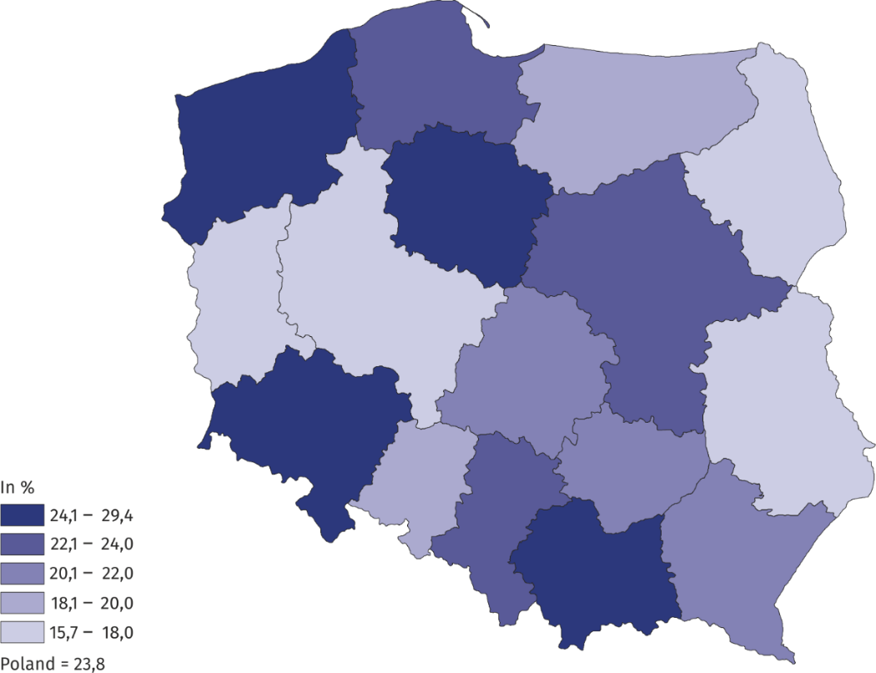**Map 2**. **Occupancy rate of bed places in tourist accommodation establishments in the first half of 2020**

.

|  |  |
| --- | --- |
| Prepared by:  [**Statistical Office in**](http://warszawa.stat.gov.pl/en/) **Rzeszów**  **Director Marek Cierpiał-Wolan** Office: tel. (+48 17) 853 52 10 | Issued by: **The Spokeperson for the President**  **of Statistics Poland** **Karolina Banaszek**Mobile: (+48) 695 255 011 |

|  |  |  |
| --- | --- | --- |
| **Press Office**  Office: tel. (+48 22) 608 34 91, 608 38 04  **e-mail:** [**obslugaprasowa@stat.gov.pl**](mailto:obslugaprasowa@stat.gov.pl) |  | www.stat.gov.pl/en/ |
|  | @StatPoland |
|  | @GlownyUrzadStatystyczny |

**Related information**

[Occupancy of tourist accommodation establishments in Poland in June and July 2020](https://stat.gov.pl/en/topics/culture-tourism-sport/tourism/occupancy-of-tourist-accommodation-establishments-in-poland-in-june-and-july-2020,5,21.html)

[Occupancy of tourist accommodation establishments in Poland in May and June 2020](https://stat.gov.pl/en/topics/culture-tourism-sport/tourism/occupancy-of-tourist-accommodation-establishments-in-poland-in-may-and-june-2020,5,20.html)

[Occupancy of tourist accommodation establishments in Poland in April and May 2020](https://stat.gov.pl/en/topics/culture-tourism-sport/tourism/occupancy-of-tourist-accommodation-establishments-in-poland-in-april-and-may-2020,5,19.html)

[Occupancy of tourist accommodation establishments in the first quarter of 2020](https://stat.gov.pl/en/topics/culture-tourism-sport/tourism/occupancy-of-tourist-accommodation-establishments-in-the-first-quarter-of-2020,5,17.html)

[Occupancy of tourist accommodation establishments in Poland in March and April 2020](https://stat.gov.pl/en/topics/culture-tourism-sport/tourism/occupancy-of-tourist-accommodation-establishments-in-poland-in-march-and-april-2020,5,16.html)

[Tourism in Poland in the face of COVID-19 pandemic](https://stat.gov.pl/en/topics/culture-tourism-sport/tourism/tourism-in-poland-in-the-face-of-covid-19-pandemic,6,1.html)

[Tourism in 2019](https://stat.gov.pl/obszary-tematyczne/kultura-turystyka-sport/turystyka/turystyka-w-2019-roku,1,17.html)

**Data available in databases**

[Local Data Bank](https://bdl.stat.gov.pl/BDL/dane/podgrup/temat)

**Terms used in official statistics**

[Tourist](https://stat.gov.pl/en/metainformations/glossary/terms-used-in-official-statistics/539,term.html" \o "Tourist)

[Tourist accommodation establishment](https://stat.gov.pl/en/metainformations/glossary/terms-used-in-official-statistics/245,term.html" \o "Tourist accommodation establishment)

[Bed places in tourist accommodation establishments](https://stat.gov.pl/en/metainformations/glossary/terms-used-in-official-statistics/1231,term.html" \o "Bed places in tourist accommodation establishments.)

[Nights spent (overnight stays) in tourist accommodation establishments.](https://stat.gov.pl/en/metainformations/glossary/terms-used-in-official-statistics/1233,term.html" \o "Nights spent (overnight stays) in tourist accommodation establishments.)

[Duration of the stay](https://stat.gov.pl/en/metainformations/glossary/terms-used-in-official-statistics/3487,term.html" \o "Duration of the stay)

[Occupancy rate of bed places or rooms](https://stat.gov.pl/en/metainformations/glossary/terms-used-in-official-statistics/1239,term.html)